**NAME…………………………..…………………………………..….CLASS……………**

**DEEPER LIFE HIGH SCHOOL**

**THIRD TERM E-LEARNING NOTES**

**JS 1 (BASIC 7)**

**SUBJECT: BUSINESS STUDIES**

**SCHEME OF WORK**

**WEEKS TOPICS**

**1. Revision/Double Entry Book-keeping:** (a) Meaning of double entry Book-keeping

(b) Double entry treatment of assets (c) Double entry treatment of liability (d) Double

Entry treatment of expenses.

**2. Double Entry Book-keeping:** (e)Meaning of journals (f) Meaning of Ledgers (g)

Classes of ledger (h) Classification of accounts: (i) Real, (ii) Nominal (iii) Personal (iv)

Impersonal.

**3. Introduction to Keyboarding:** (a) keyboarding: (i) Meaning (ii) Importance (iii)

Correct sitting posture for keyboarding.

**4. Parts of a Computer Keyboard:** (a) Parts of the Computer keyboard. (b) Uses

(functions) of parts of the computer keyboard. (c) Similarities between the typewriter

and computer keyboards.

**5. Care of the Computer and Correct keyboarding techniques:** (a) Care of the

computer (b) Items used for the care of the Computer (c) The keyboard rows:Top,

Upper, Home, Nottem (d) Divisions of the keyboard. – Left hand side, Right hand side.

**6. Home Row Keys (Keyboarding Applications):** (a) The keyboard rows:(i)Top

(ii) Upper (iii) Home ()iv Nottem (b) Two divisions of the keyboard: (i) Left hand side

(ii)Right hand side.

**7. Mid-term break**

**8. Alphanumeric Keys (Keyboarding Applications):** Alphanumeric keys: (i)

Identification (ii) Soft touch manipulation.

**8. Basic Service Keys (Keyboarding Applications):** (a) Correct finger placement on

The basic service keys (b) The manipulation of the basic service keys using soft touch.

**9. Correct Spacing and Punctuation Marks (Keyboarding Applications):**

(i) Identification (ii) Correct finger placement (iii) Correct use of punctuation mark keys

(iv) Correct spacing after punctuation marks.

**10. Revision.**

**11 – 13. Examination.**

**WEEK 1.**

**TOPIC: REVISION/DOUBLE ENTRY BOOK-KEEPING**

**Date: ……………………………………..**

**CONTENTS:**

(a) Meaning of double entry Book-keeping

(b) Double entry treatment of assets

(c) Double entry treatment of liability

(d) Double entry treatment of expenses.

**(A) MEANING OF DOUBLE ENTRY BOOK-KEEPING**

Double entry book-keeping means every debit entry must have a corresponding credit entry. This is a principle or rule that is followed globally in book-keeping system.

**Further Explanation**

The fundamental concept of accounting is that every business transaction in money or money-worth has two effects: the receipts of a benefit by one account and the giving of a like benefit by another account. Thus, if a value is given, it is also received. The meaning of this is that where there is a giver, there is also a receiver who is called a debtor. The first Golden Rule of bookkeeping therefore states that, **you debit the receiver and credit the giver.**

In the process of debiting the account receiving the value and crediting the account surrendering the value, you end up recording every transaction twice, once as a debit entry and again as a credit entry. In effect, **every credit entry must have a corresponding debit entry, and every debit must have a corresponding credit entry.**

|  |  |
| --- | --- |
| DR | CR |
|  |  |

The double entry system divides the page into two halves as shown above. Every business that is established must have assets, liabilities, and capital

**An Asset is anything of value that is owned by a business. A liability is an amount owed by a business to others, while Capital is the total investment in a business.**

Therefore, an account is opened for every asset owned by a business and every liability owed by the business. Each account has a separate title and page given to it

**(B) DOUBLE ENTRY TREATMENT OF ASSET**

Examples: Olundi, a wood seller, started business on January 1 with N5000 in cash. He purchased the following to enable him run the business.

Jan 9. He bought furniture from Londa & Co. Ltd. For N2000 in cash

Jan 12. He bought office equipment from Banuna & Co. Ltd. For N1000.

SOLUTION:

Jan 1. B. Olundi started business with N5000 cash as capital. With this introduction of N5000 into the business, two accounts should be opened. The capital account gave the money and should be credited, while the cash account received the money and should be debited.

Jan 9. On the purchase of furniture from Londa & Co. Ltd. For cash, the cash account will be credited because the account gave out the money, while the furniture Account will be debited for receiving the value of N2000.

Jan 12. He purchased office equipment from Banuna & Co. Ltd. The office account will be debited for receiving the value of N1000 while the cash account will be credited for giving the money.

**CASH ACCOUNT**

|  |  |
| --- | --- |
| **DR CR** | |
| **Jan 1. To capital a/c 5000.00** | **Jan 9.Furniture 2000.00** |
|  | **Jan 10.Office equipment a/c 1000.00** |
|  | **31 Balance c/d 2000.00** |
| **5000.00** | **5000.00** |
|  |  |
|  |  |
| **Feb 1 2000.00** |  |

**CAPITAL ACCOUNT**

**Dr Cr**

|  |  |
| --- | --- |
|  | **N** |
|  | **Jan1. To cash a/c 5000** |

**FURNITURE ACCOUNT**

**Dr Cr**

|  |  |
| --- | --- |
| **N** |  |
| **Jan 1. To cash a/c 2000.00** |  |

**OFFICE EQUIPMENT ACCOUNT**

**Dr Cr**

|  |  |
| --- | --- |
| **Jan12 to cash a/c 1000.00** |  |
|  |  |

**(C) DOUBLE ENTRY TREATMENT OF LIABILITIES**

Liabilities are debts owed by a business to others. For example, if Mr. Akinola sells good to Mr. Adewale worth N10,000 on credit. Mr. Akinola must keep a record to show that there is some money due from Mr. Adewale. Credit transactions involve the opening of **Personal Account.** A personal account is an account which bears the name of the a customer or a supplier.

Example:

January 10 Bought on credit from Amadu Electronics Company, an electric Cooker worth N10,000

January 24 Sold on credit goods worth N25,000 to B. Solape

The two accounts will be opened for the credit transactions as follows

Dr **Amadu Electronics Company Account** Cr

|  |  |
| --- | --- |
|  | N  Jan 10 Purchases 10,000 |

Dr **Purchases Account** Cr

|  |  |
| --- | --- |
| N  Jan 10 Amadu Electronics Company 10,000 | N  Jan 31 Balance c/d 10,000 |

Dr **B. Solape Account** Cr

|  |  |
| --- | --- |
| N  Jan 24 Sales 25,000 |  |

Dr **Sales Account** Cr

|  |  |
| --- | --- |
| N  Jan 31 Balance c/d 25,000 | N  Jan 24 B. Solape 25,000 |

**(D) DOUBLE ENTRY TREATMENT OF EXPENSES**

Expenses mean spending money belonging to a business to gain more money. It is recorded on the debit side of the books.

Types of expenses: rent, wages/salaries, postages, stationery, insurance telephone, electricity, motor expenses etc.

Example:

June 12 Vehicle expenses of N2000 paid by cheque.

Solution: Credit Bank account, and debit Vehicle expenses account

Dr **Bank** Cr

|  |  |
| --- | --- |
|  | N  Jan 10 Vehicle expenses 2,000 |

Dr **Vehicle Expenses** Cr

|  |  |
| --- | --- |
| N  June 12 Bank 2,000 |  |

**Evaluation:**

1. What do you understand by Double Entry book-keeping?

**WEEK 2.**

**TOPIC: DOUBLE ENTRY BOOK-KEEPING**

**Date: ……………………………………..**

**CONTENTS:**

(e)Meaning of journals

(f) Meaning of Ledgers

(g) Classes of ledger

(h) Classification of accounts: (i) Real, (ii) Nominal (iii) Personal (iv) Impersonal.

**(E) MEANING OF JOURNALS**

**Journals are documents which contain the daily records of business transactions.** Information from source documents are first recorded in journals before being transferred to the principal books of account. Journals are called day books because they need to be updated daily. Each record in a journal is called an entry. Journals are also called **books of original entry** or **books of prime entry** because the entries are transferred to a second book i.e principal book of account.

**(F) MEANING OF LEDGERS**

**Ledgers are principal books of account used to record the weekly and monthly transactions from the journal entries**. It is therefore called a book of second or secondary entry because transactions are transferred from the journal entries to it.

**(G) CLASSES OF LEDGER**

The following are classes of ledger we have:

**(i) Sales Ledger:** This contains a separate account for each individual to whom goods have been sold, or for whom services have been performed on credit. It is also called Debtor’s Ledger.

**(ii) Purchases Ledger:** This contains the personal accounts of those who have supplied goods or rendered services to the business on credit.

**(iii) General Ledger:** It is a ledger in which real and nominal accounts are kept.

**(iv) Private Ledger:** This is a confidential ledger kept by either the proprietor (owner of business) or the Accountant outside the reach of the other staff.

**(v) Loose-leaf ledger:** This consists of separate sheets printed in ledger ruling.

**(vi) Card Ledger:** This consists of a printed card for each customer or supplier as appropriate. The cards are arranged in an orderly manner and filed in special cabinet.

**(H) CLASSIFICATION OF AN ACCOUNT**

(i) **Real Accounts:** These accounts contain records of transactions in property or materials i.e things you can see physically. Examples are motor vehicle accounts, furniture account, buildings account, machinery account etc.

(ii) **Nominal Accounts:** These deal with intangible things which may be revenue, losses, expenses, goodwill, profits and discounts.

(iii) **Personal Accounts:** These are accounts in which transactions with individuals or other organizations are entered. Examples of personal accounts are debtors and creditors accounts.

(iv) **Impersonal Accounts:** These accounts relate to intangible and material things. It is the one sub-divided into real accounts and nominal accounts.

**Evaluation:**

1. Explain the term ‘‘Ledger’’

2. List the classes of ledger.

**Reading Assignment:**

Business Studies for Junior Secondary Sc hool Book 1 produced by Cross River State Government, Chapter 8 pages 46-49.

**Weekend Assignment:**

Objective Questions:

1. Double-entry book-keepping is a system in which accounts are recorded on the __________ a. assets side only b. management and staff corner c. selling activities side d. fixed assets and current assets e. giving and receiving aspects of a financial transaction.
2. An asset in book-keeping is ___________ a. anything of value owned by a business b. the money the business started with. C. the amount owed by a business d. all goods sold by a business e. all goods purchased for consumption by a business.
3. The term “folio” means _____________ a. a special type of ledger b. a system of stock taking c. a book of original entry d. a method of calculating depreciation e. a page in a book of accounts.
4. Mariam Osondu bought goods woth N25 000 from Tunde Adams on credit. How will this transaction be recorded in the ledger of the buyer? A. debit Mariam Osondo, credit Tunde Adams b. debit Tunde Adams, credit sales account c. debit purchases account, credit Tunde Adams d. debit Tunde Adams, credit sales account e. debit Mariam Osondu, credit sales account.
5. Which fo the following is not a book of accounts? A. csh book b. petty cash book c. journal d. directory e. ledger.
6. The book of accounts used by book-keepers to summarise and keep a permanent record of all financial transactions is called__________ a. cash book b. sales day bok c. journal d. purchases day book. e ledger.

Essay

1. What is Double Entry in Book-Keeping?
2. Show the accounts to be debited and those to be credited in the following cases:
   1. Paid rent by cheque
   2. Paid wages by cash
   3. General expenses by cash
3. Enter the following transactions in the appropriate accounts in double entry form and show the balance as of 10th June

June 1 Started business with N200,000.00 in cash

June 3 A. Amadi loaned the business N50,000.00 and remitted the money

by cash

June 5 Bought goods for resale on credit for N150,000 from B. Balogun

June 7 Bought bicycle for the use of the company and paid by cash

N15,000.00

June 8 Cash Sales N20,000.00

June 10. Paid wages in cash N25,000.00

**WEEK 3.**

**TOPIC: INTRODUCTION TO KEYBOARDING**

**Date: ……………………………………..**

**CONTENTS:**

(i) Meaning of keyboarding

(ii) Importance of keyboarding

(iii) Correct sitting posture for keyboarding.

**(i) MEANING OF KEYBOARDING**

Keyboarding is the act of using special machines like typewriter and computer to produce valuable documents in mail-able form. It is also the utilization of a keyboard for computer functions and typing.

**(ii) IMPORTANCE OF KEYBOARDING**

Importance of keyboarding includes the following:

1. it makes production of documents easier than the use of pen.
2. it provides neater and clearer documents.
3. it provides various job opportunities.
4. It will help and individual develop good communication skill.
5. It would increase individual productivity and thereby increasing business turnover.

**(iii) CORRECT SITTING POSTURE FOR KEYBOARDING**

Efficiency in keyboarding can be achieved only if a suitable chair and table is used. Each should be placed at the correct height for the typist. For a correct sitting position, the under listed points should be observed:

1. Places your book or the manuscript on the right hand side of the machine or as directed by the teacher or instructor to avoid obstruction.

2. Your fingertips should be placed on the home keys/guide keys; ASDF for the left hand and; LKJ for the right hand

3. Assign numbers to the fingers.

4. Keep your left thumb close to your left first finger.

5. Extend your right thumb so that it is slightly above the Centre of the space bar

6. At this juncture, check you posture

a. Your arms should hang naturally at your sides with elbows well positioned.

b. Hold your head erect facing the book.

c. Hold your shoulder back and relax.

d. Position yourself opposite the ‘j’ key.

e. Straighten your back with your body slopping slightly forward from the hips.

f. Sit in an upright position.

g. Feet should be firmly placed on the floor, preferably with one slightly in front of

the other to give balance.

h. Wrist to be kept low and straight.

i. Never type while looking at the keyboard.

**FINGER MOVEMENT DRILL (Preliminary Practice):** Knowing the finger movement or mastering the finger movement is very important in learning how to type. It is because of this that the preliminary practice of finger movement is important.

**Finger movement drill is practiced thus:**

**Step 1:** For the exercise you want to type, practice the finger movement without typing. This practice should continue until your fingers know when to move from the home keys.

**Step 2:** During this preliminary practice, you may look at your fingers, by so doing; you will find it helpful to say the letters to yourself. But always remember to return your fingers to the home guide keys.

***Step 3*:** When you are sure that your fingers have acquired the correct movement, the practice has to be repeated without looking at your fingers. Your eyes has to be kept on the copy or in your book and do not strike the keys. If you find it difficult making the finger movement, go back and repeat step 1 above.

Having seated correctly at the machine, strike each key lightly but firmly with the finger tips. During this process, the carriage will come automatically from right to left margin of the machine. Making sure that only one key is struck to avoid keys jamming at the printing point.

Strike the space bar smoothly with the right-hand thumb to obtain the necessary space after the word. But to begin a new line, return the carriage with the help of the carriage return lever. This will turn on a new line simultaneously. After striking, return all fingers to the home or guide keys immediately.

Before preparing to type, it will be worthwhile to look at your work on the machine. The more you keep your eyes on the copy and hands on the keyboard, the faster and more accurate you will be.

Finally, a good sitting position will give comfort; reduce fatigue and inaccuracy in typing.

**Evaluation**:

1. Define keyboarding.

2. List three importance of keyboarding.

3. List the home keys.

4. List and briefly explain three guidelines to consider in a correct keyboarding posture.

**WEEK 4.**

**TOPIC: PARTS OF A COMPUTER KEYBOARD**

**Date: ……………………………………..**

**CONTENTS:**

(a) Parts of the computer keyboard

– Uses (functions) of the parts the computer keyboard.

(b) Similarities between the typewriter and computer keyboards.

**EXPLANATION**

Before we actually look into the parts of computer keyboard, let us look at the meaning of keyboard. **Keyboard is an input device used to feed data into the computer system.**

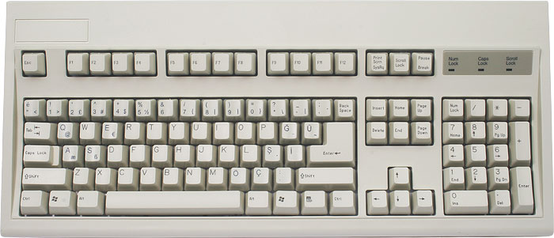

**A KEYBOARD**

**(A) PARTS OF THE COMPUTER KEYBOARD.**

i. Alphabetical keys

ii. Numerical keys

iii. Special character keys

iv. Control keys

v. Function keys

vi. Caps lock key

vii. Alternate key

viii. Space bar key

ix. Back space key

x. Escape key

xi. Shift key

xii. Tab Key

xiii. Home keys

xiv. Delete key

xv. Arrow keys

xvi. Enter/ Return key

**USES (FUNCTIONS) OF THE PARTS COMPUTER KEYBOARD**

i. **Alphabetical keys:** They are keys used to type-in alphabets into computer system.

ii. **Numerical keys:** They are above the alphabets. They are used to type-in numbers into computer system.

iii. **Special Character keys:** They are keys used for special characters. They share the same keys with numerical keys but are written at the upper part. Examples are: % @ ! $ * & ^ etc. Shift key will first be pressed down before special characters can be used.

iv. **Control Keys:** It is used to execute command with other key(s).

v. **Functions keys:** They are used alone or with the Ctrl, Alt and Shift keys to execute software commands. They are located at the top of the keyboard ( F1, F2, F3, etc).

vi. **Caps Lock Key:** It is a toggle key i. e. on/off. It is used to shift from the lower case character to the upper case characters and vice versa. When it is pressed, the cap lock indicator light will be on and all characters are in upper cases.

vii. **Alternate key (Alt):** This is located at the left of the space bar. It is known as the alternate key and used to execute commands with other key(s).

viii. **Space Bar key:** It is used to insert space between words and sentences. It moves the cursor to the right when pressed and leaves spaces in-between texts when pressed.

ix**. Back Space key:** It erases character to the left when pressed.

x. **Escape key (Esc):** It is used to close a software menu or dialogue box.

Xi. **Shift key:** It is used to make capital letters and certain symbols when used with those keys.

xii. **Tab Key:** It is used to move the insertion point to a preset position.

xiii. **Home keys:** These are keys where you place your fingers to begin keying. They are: a s d f for the left hand and j k l ; for the right hand.

xiv. **Delete key:** It is used to remove the character to the right of the insertion point.

xv. **Arrow keys:** They are used to move the insertion point in the direction indicated by the arrow on each key.

xvi. **Enter/ Return key:** It is used to cause the insertion point to move to the left margin and down to the next line.

**(B) SIMILARITIES BETWEEN THE TYPEWRITER AND COMPUTER KEYBOARD**

1. The two have same text character.
2. They both produce documents in mailable form.
3. They both receive data with the help of an input device.
4. The both process data.
5. The both store data.

**Evaluation**

1. List seven computer keys and their functions.
2. State the similarities between the typewriter and computer keyboard.

**WEEK 5.**

**TOPIC: CARE OF THE COMPUTER AND CORRECT KEYBOARDING TECHNIQUES**

**Date: ……………………………………..**

**CONTENTS:**

(a) Care of the computer

(b) Items used for the care of the Computer

(c) The keyboard rows:Top, Upper, Home, Nottem

(d) Divisions of the keyboard. – Left hand side, Right hand side.

**(A) CARE OF THE COMPUTER.**

1. Clean the visible parts of the computer to ensure there is no dust or particles that can enter the machine.
2. Clean the disk drives.
3. Shut down the computer properly after use to avoid damage to your system and loss of documents.
4. Provide adequate electrical supply for the computer.
5. Use the right furniture, both table and chair for maximum use of the machine.
6. Do not bring food items near the computer.
7. Do not touch the exposed part of the disk.
8. Do not plug your computer to a line that has other high electricity consuming items like refrigerator, water heater etc.
9. Cover your computer system when not in use to prevent dust.
10. Provide air conditioner for the computer.
11. Consult a computer engineer in case of any fault.

**(B) ITEMS USED FOR THE CARE OF THE COMPUTER**

(i) Blower

(ii) Duster

(iii) Brush

1. A piece of clean rag that is not wet
2. Computer system cover.
3. Anti-virus software.

**Evaluation:**

1. Itemize 5 ways to care for the computer.

**(C) THE KEYBOARD ROWS: Top, Upper, Home, Nottem.**

Keyboard rows are: Top row, Upper row, Home keys row and Nottem row.

1. **Top row:** This row consists Arabic numerals from 1 to 0, hyphen and equal to keys. On the top of this numbers are signs; other characters may appear depending on the type of machine. These characters are depressed with the aid of the shift key. 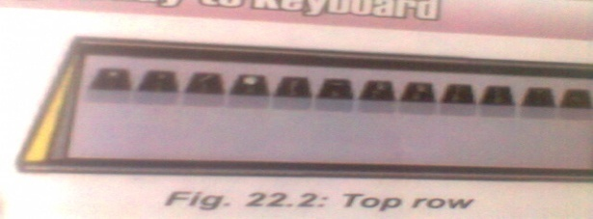
2. **Upper Row:** This row is also known as the second row. It contains the following alphabets: q, w, e, r, t, y, u, i, o, p. At the depression of the shift key, the capital letter of this character will be typed. 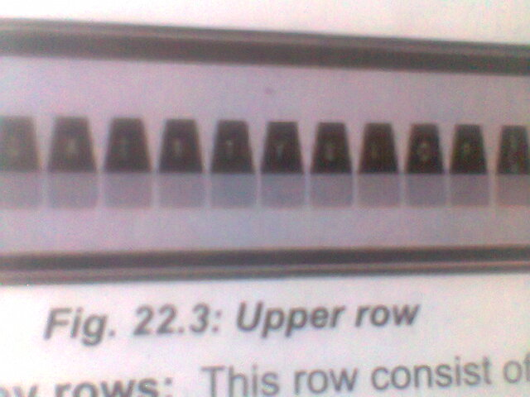
3. **Home Key Rows:** This row consist of a, s, d, f, g, h, j, k, l, when you depress the shift key the capital letter will show on the typing sheet. 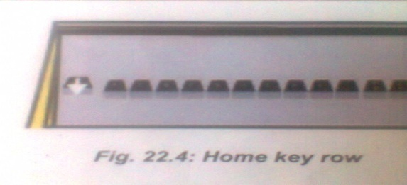
4. **Nottem Row:** It is also known as the bottom row or the third row key. It consist z, x, c, v, b, n, m, comma(,) and full stop(.) keys. When the shift key is depressed, these characters will appear in capital letter or upper case character.

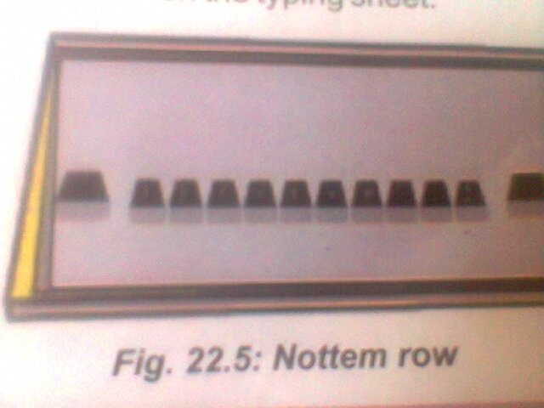

**(D) DIVISIONS OF THE KEYBOARD**

Keyboard is divided into two:

1. The left hand side

2. The right hand side.

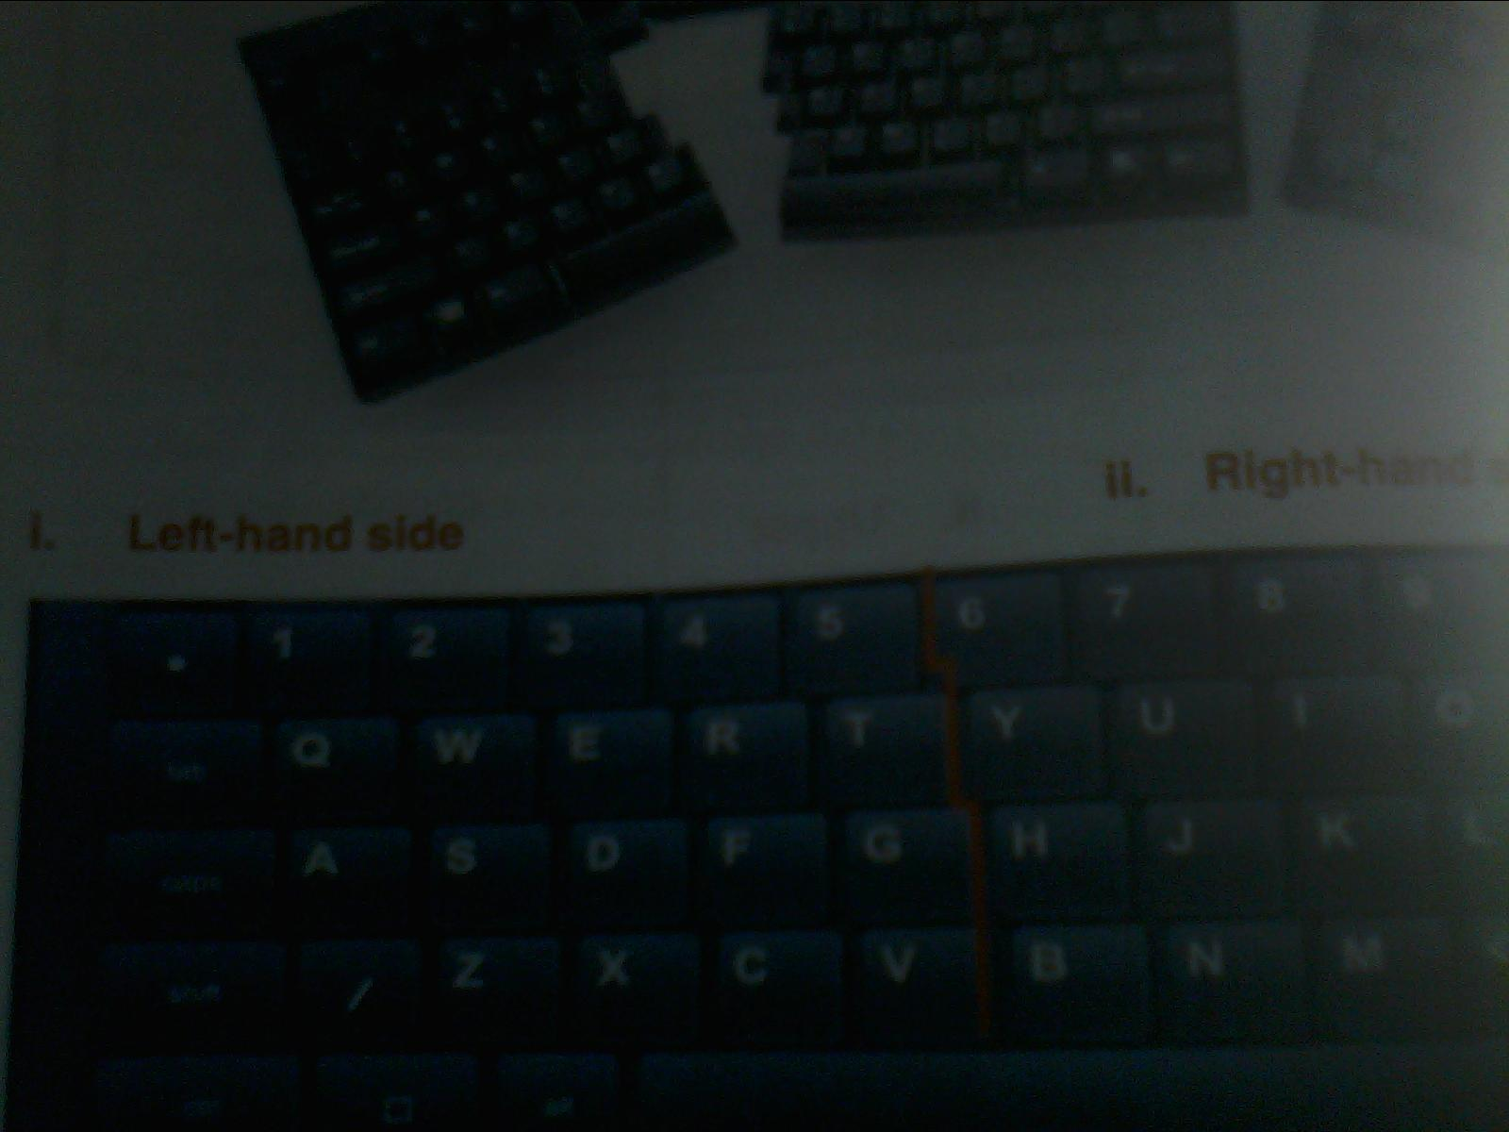

The left hand is used to depress a, s, d, f and g on the home row, while the right hand is used to depress (;, l, k, j, h) on the same row.

**Evaluation:**

1. Mention the four keyboard rows.

2. Explain the division of the keyboard.

**Assignment:** Nelson Business Studies for JSS workbook 1, pages 71 and 72.

**WEEK 6.**

**TOPIC: HOME ROW KEYS (KEYBOARDING APPLICATIONS)**

**Date: ……………………………………..**

**NOTE** – Identification, demonstration, manipulation/application of the keyboard rows are to be done majorly here. Students are to:

* Observe the position of the four rows of the keyboard (Top, Upper, Home, Nottem) and point them out as shown to them by the teacher.
* Practice proper finger placement on the home row keys as demonstrated by the teacher.
* Practice how to manipulate the home row keys using soft touch as demonstrated by the teacher.

**CONTENTS:**

(a) The keyboard rows:(i) Top (ii) Upper (iii) Home (iv) Nottem

(b) Two divisions of the keyboard: (i) Left hand side (ii) Right hand side.

**(A) THE KEYBOARD ROWS: (I) TOP (II) UPPER (III) HOME (IV) NOTTEM**

**EXPLANATION**

**CORRECT FINGER POSITION ON THE HOME KEYS.**

The four fingers excluding the thumb of the left hand are placed on “asdf” while the four fingers of the right hand are placed on”;lkj”. It is from here that the fingers move up and down the entire keyboard. “asdf and ;lkj” are therefore called home keys. First of all, master the keyboard to know the positions of the keys, and then type without looking at the keyboard but the copy.

**CORRECT FINGER MOVEMENT ON THE HOME KEYS.**

After placing the fingers on the home keys, the fingers should strike a key at a time to avoid key jam. The two little fingers are used to strike the guide keys (a & ;). The remaining fingers on the left except the left and right thumb are used to strike “sdf” while the rest fingers on the right hand are used to strike “lkj”.

Activity: practice exercise 1 from Walmsley’s Commercial Typewriting by Aileen M Prince

**CORRECT WAYS FOR FINGERS POSITION ON THE TOP ROW, UPPER ROW, HOME ROW AND NOTTEM ROW**

**THE TOP ROW**

Figures play one of the most important parts in typewriting. Since numerical errors in any piece of typewritten work may cause much harm, therefore maximum concentration on the correct fingering in the very early stages of training is very important to attain that degree of efficiency required.

However, this section of the keyboard training mastery deals with the row of keys which introduces the Arabic numerals (1 to 0) and the hyphen.

ACTIVITY: Practice exercises 42 and 43 from Walmsley’s Commercial Typewriting by Aileen M Prince

**THE UPPER ROW/THE SECOND ROW**

When the correct position at the machine has been taken up and the fingers have been placed on the home keys, the keys of the second row can be operated and memorized. They are in a position above and slightly to the left of their corresponding keys in the second row. In order to associate correctly the keys of the second and third rows, the first practice will be to reach from the home keys to the third row. With the little finger of the left hand strike the guide key a. With the same finger reach upwards and slightly to the left to strike the q key, and then return the finger to the second row and again strike the key for a. The movement should be repeated several times, with a space between each series of letters.

4 3 2 1 1 2 3 4

4 3 2 2 3

**Q**

**O**

**P**

**I**

**R**

**T**

**Y**

**U**

**E**

**W**

Note: 1 represent the index finger, 2 represent the middle finger, 3 represent the ring finger and 4 stands for the little finger.

Activity: practice exercise 10

frf ftf juj jyj frf ftf juj jyj;

frf ftf juj jyj frf ftf juj jyj;

red get yes hug rid yet dye due;

her ate say hue sir fit fly hut;

are the hay fur rat its day rue;

**THE HOME ROW**

The remaining keys (letters) on the home row are” g, h”. The fourth finger on the left hand side and the fourth finger on the right hand side are used to strike these keys. The f finger strikes g while the j finger strikes h. The fingers should be returned immediately after striking the keys.

4 3 2 1 1 2 3 4

**a**

**l**

**;**

**k**

**f**

**g**

**h**

**j**

**d**

**s**

Note: 1 represent the index finger, 2 represent the middle finger, 3 represent the ring finger and 4 stands for the little finger. Note also that the counting is from ‘‘f’’ finger i.e. the finger on key ‘‘f’’ is the 1st finger, the finger on key ‘‘d’’ is the 2nd finger, the finger on key ‘‘s’’ is the 3rd finger while the little finger which is on key ‘‘a’’ is the 4th finger, all on the left hand side. For the right hand side, the finger on key ‘‘j’’ is the 1st finger, the finger on key ‘‘k’’ is the 2nd finger, the finger on key ‘‘l’’ is the 3rd finger, while the little finger on key ‘‘;’’ is the 4th finger, all on the right hand side.

Activity: practice exercises 2, 3, and 4 from Walmsley’s Commercial Typewriting by Aileen M Prince

**NOTTEM ROW/THIRD ROW**

As learned in our previous lesson, Nottem row is also known as the bottom row or the third row key. It consists of z, x, c, v, b, n, m, comma (,) and full stop (.) keys. The 1st finger on the left hand side is used to press key ‘‘v’’, the 2nd finger is used to press key ‘‘c’’, the 3rd finger is used to press key ‘‘x’’, while the 4th finger i.e. the little finger is used to press key ‘‘z’’. For the right hand side, the 1st finger is used to press key ‘‘n’’, the 2nd finger is used to press key ‘‘m’’, the 3rd finger is used to press comma key, while the 4th finger i.e.the little finger is used to press the full stop key. For key ‘‘b’’, the 1st finger on the left hand side, i.e. the ‘‘f’’ finger is used for it.

**CORRECT FINGER POSITION AND MOVEMENT FOR SPECIAL CHARACTERS AND FIGURES.**

The special characters and figures are located on the top row. To effectively type these keys, one needs to associate them with the home and the third row. To type the special characters, depress the shift key.

Activity: practice exercises 44 to 46 from Walmsley’s Commercial Typewriting by Aileen M Prince.

**(B) TWO DIVISIONS OF THE KEYBOARD: (I) LEFT HAND SIDE (II) RIGHT HAND SIDE.**

Keyboard is divided into two:

1. The left hand side

2. The right hand side.

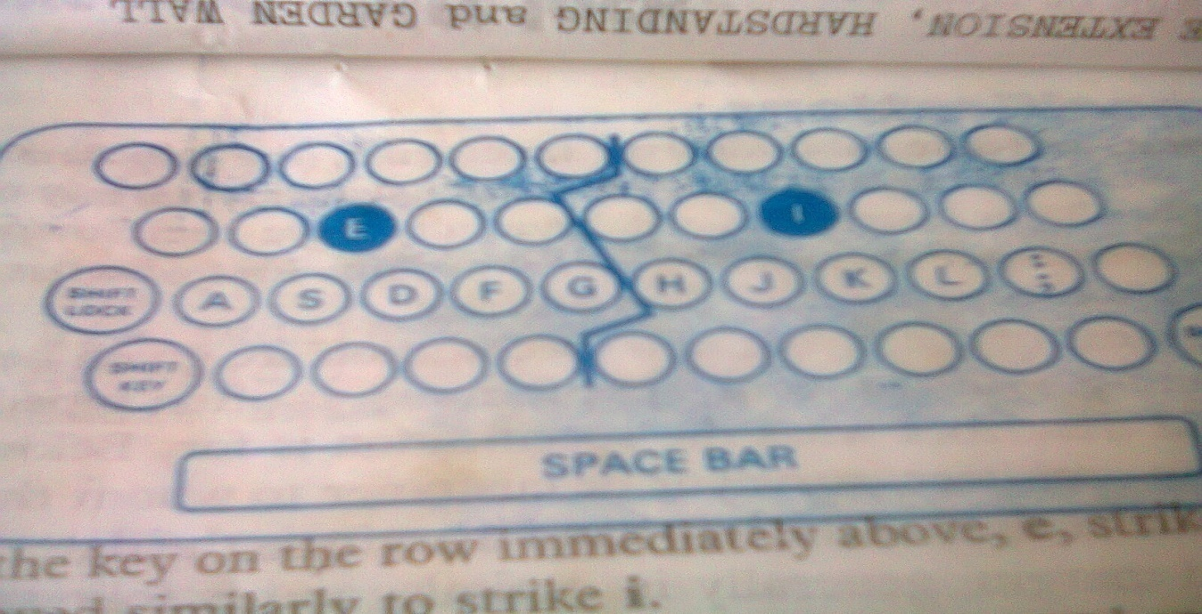

The left hand is used to depress a, s, d, f and g on the home row, while the right hand is used to depress (;, l, k, j, h) on the same row.

**References:**

‘Walmsley’s Commercial Typewriting’ Eighth Edition by Aileen M Prince

Paragon Typewriting bk1 by Robert Esene.

Nelson Business Studies for Junior Secondary Schools, bk. 1 published jointly by Nigeria Educational Research and Development.

**WEEK 7.**

**TOPIC: ALPHANUMERIC KEYS (KEYBOARDING APPLICATIONS)**

**Date: ……………………………………..**

**CONTENTS:**

(a) Alphanumeric keys:

(i) Identification

(ii) Soft touch manipulation.

**(A) ALPHANUMERIC KEYS**

These are keys of all the alphabets (a – z) and numbers (0 - 9).

The alphanumeric keys also include symbols at the upper part of the number row such as exclamation mark (!), at (@), ampersand (&) etc.

**(I) IDENTIFICATION**

Here, learners are to properly identify all the alphanumeric keys. The keys are to be shown to the learners by the teacher.

**CORRECT FINGER PLACEMENT ON ALPHANUMERIC KEYS.**

For fingers to use on alphabets, refer to the previous lesson i.e week 6 on keyboard rows particularly the areas highlighted in yellow colour above. For the numeric keys, the 1st finger on the left hand side will press key ‘‘4’’, the 2nd finger will press key ‘‘3’’, the 3rd finger will press key ‘‘2’’, while the 4th finger which is the little finger will press key ‘‘1’’. For the right hand side, the 1st finger will press key ‘‘7’’, the 2nd finger will press key ‘‘8’’, the 3rd finger will press key ‘‘9’’, while the 4th finger which is the little finger will press key ‘‘0’’. For key ‘‘5’’, the 1st finger on the left hand is used to press it and for key ‘‘6’’, the 1st finger on the right hand side is used to press it. Note that “asdf and ;lkj” are called home keys. First of all, master the keyboard to know the positions of the keys, and then type without looking at the keyboard but the copy.

**(II) SOFT TOUCH MANIPULATION.**

After placing the fingers on the home keys, the fingers should move softly to touch/strike any of the alphanumeric keys and manipulate document to type. The soft touch is very important so as to avoid key jam.

**Activity 1:** Demonstrate correct fingers placement on the following as your teacher observes you:

* Home keys. From the home keys, move your fingers to:
* Top row
* Upper row
* Nothem row.

**Activity 2:** With soft touch, manipulate the alphanumeric keys to practice typing

**Activity 3:** practice exercise 1 from Walmsley’s Commercial Typewriting by Aileen M Prince.

**WEEK 8.**

**TOPIC: BASIC SERVICE KEYS (KEYBOARDING APPLICATIONS)**

**Date: ……………………………………..**

**CONTENTS:**

(a) Correct finger placement on the basic service keys

(b) The manipulation of the basic service keys using soft touch

**BASIC SERVICE KEYS**

These are special keys that allow you to use computer to perform specific functions. Examples are: space bar, tab key, caps lock key, control key, shift key, delete key, return key, Alt key, home and end , insert and arrow keys.

**(a) CORRECT FINGER PLACEMENT ON BASIC SERVICE KEYS**

(i) Space bar: Although both thumbs are placed on it but the right thumb is used to press it when typing.

(ii) Tab key: The 4th finger (little finger) on the left hand is placed on it and used to press it.

(iii) Caps lock key: The 4th finger (little finger) on the left hand is placed on it and used to press it.

(iv) Control key: Either the 4th finger (little finger) on the left hand or the 4th finger (little finger) on the right hand is placed on it and used to press it because we have Control key on the two sides of keyboard.

(v) Shift key: Either the 4th finger (little finger) on the left hand or the 4th finger (little finger) on the right hand is placed on it and used to press it because we have Shift key on the two sides of keyboard.

(vi) Return (Enter) key: The 4th finger (little finger) on the left hand is placed on it and used to press it.

When special keys are used with a single letter, they become shortcut keys. Example ctrl+S. others include:

|  |  |
| --- | --- |
| **Shortcut keys** | **Description** |
| Alt + F | File menu options in current program |
| Alt + E | Edit option in current program. |
| Ctrl + A | Select all text. |
| Ctrl + X | Cut selected item. |
| Shift + Del | Cut selected ttem. |
| Ctrl + C | Copy selected item. |
| Ctrl + LV | Paste. |

**(B) THE MANIPULATION OF THE BASIC SERVICE KEYS USING SOFT TOUCH**

The Basic Service keys are manipulated or applied by softly touching them with the fingers mentioned above.

Note: educators are to engage the students in keyboarding practical using any recommended text for Business Studies to boost their typing skill.

**EVALUATION**

1. Explain Basic Service Keys and give three examples

2. Explain finger placement on the following Basic Service Keys:

(i) Shift key

(ii) Return (Enter) key

**WEEK 9.**

**TOPIC: CORRECT SPACING AND PUNCTUATION MARKS (KEYBOARDING APPLICATIONS)**

**Date: ……………………………………..**

**CONTENTS:**

(i) Identification

(ii) Correct finger placement

(iii) Correct use of punctuation mark keys

(iv) Correct spacing after punctuation marks.

**(I)DENTIFICATION AND USES OF SPACING KEYS**

Spacing keys are special keyboard characters that are used to give appropriate characters that are used tp give gap(s) in between words or typing lines.

They are as follows:

1. Backspace: this moves the carriage or cursor one space at a time. It is usually typed with the weak or pinky finger on the right hand. it is used to erase characters from the end.
2. Line space regulator: this controls the spaces between lines of typing. It can be adjusted by the right or left hand. it allows for 1, 1½ , 2 and 3 line spacing.
3. Space bar: this is a rectangular bar at the bottom of a typewriter or computer. When touched, it gives space between characters. It is usually typed with the thumb especially the right thumb.

Some of the punctuation marks on keyboard are: , . ? ‘‘’’ ; : () !

**(II) CORRECT FINGER PLACEMENT**

After fingers are properly placed on the home keys, the right and left thumbs should be dangling on the space bar. The right thumb is used to press the space bar whenever the need arises to give space. For correct finger placement on punctuation marks, the 3rd finger on the right hand side is used to press comma key, while the 4th finger i.e. the little finger is used to press the full stop key. These are on the Nottem row. For the punctuation marks that are on the Home row, the 4th finger on the right hand which is the little finger is placed on semi-colon (;) and also used to press the apostrophe (‘). Also, the 4th finger on the left hand is placed on exclamation mark (!) which is found on the top row where numeric numbers are. The 3rd and 4th fingers on the right hand are placed on the brackets which is also known as parentheses.

**(III) CORRECT USE OF PUNCTUATION MARK KEYS**

Punctuation marks are used in sentences to separate sentences or parts of sentences and to make their meaning clear. Punctuation mark keys are to be correctly used when typing. The keys are to be mastered for effectiveness as wrong use of them will affect the correctness of what we are typing.

**(IV) CORRECT SPACING AFTER PUNCTUATION MARKS.**

After a punctuation mark, there will usually be a commensurate number of spaces to be left before typing the next word. The punctuation marks, their uses and the number of spaces to be left before the next word are listed below:

**Full Stop/Period (.)**

A full stop (.) is usually used at the end of a sentence. After a full stop, two spaces must be left before starting the next sentence. An example is : Ade works in our office. A full stop can also be used as a decimal point.

Examples of these are:

#5.00 #20.00 #33.00 #20.40

**Comma (,)**

This is to indicate a slight pause in a sentence. One space must be left after a comma. An example is:

Titi said she would be here tomorrow, but she asked me to telephone her to confirm tonight.

**Semi-Colon (;)**

It is used to indicate a pause in a sentence where the second clause is closely linked with the first. One space is left after a semi-colon. An example is:

Erase thoroughly; retype the word lightly.

**Colon (:)**

This is used in directing a special attention to what follows or separate parts of a compound sentence. Two spaces are left after a colon.

Examples are:

a. The following are the names of the candidates:

b. application for leave: Mr. A. O. Dumuje.

**Question Mark (?)**

It is used after a question. Two spaces are given after a question mark. An example is:

Where did you go?

**Brackets/parenthesis()**

**This** is used to enclose clauses or sentences explaining thr leading idea of a sentence. One space is usually left after a bracket/parenthesis.

An example is:

We need (a) 5 sacks of salt and (b) 28 packs of lard.

**Dash/Hypen (-)**

This is used in place of comma. One space is given before and after a dash is typed. An example is:

I may not wish-in the initial stage to attend.

**Apostrophe (‘)**

It is used to replace ‘I’ or ‘no’ to make hours meaningful and to quote a word or figure which needs special attention. No space is given after it is typed.

Examples:

a. It’s not mine. I can’t come tomorrow.

b. It is Nze’s property

c. Use a ‘pay-in slip’ when depositing your money.

**Activity:**

1. Demonstrate correct fingers placement on the punctuation mark keys while you are

observed by the teacher.

2. Manipulate the keys by applying them to type.

**Weekend Assignment**

1. Another name for Caps lock key is known as (a) Shift key (b) Toggle key (c)

Function key (d) Keyboard key.

2. Enter key is also known as (a) Return key (b) Tab key (c) Alternate key (d) Delete

key

3. The right thumb is used to press _________ when typing (a) Backspace (b)

Question Mark (c) Space bar (d) Enter

4. Which of the fingers is used for exclamation mark? (a) 4th finger on right hand

(b) 4th finger on left hand (c) 1st finger on left hand (d) 2nd finger on left hand.

**WEEK 10. Revision.**

**WEEK 11 – 12. Examination.**